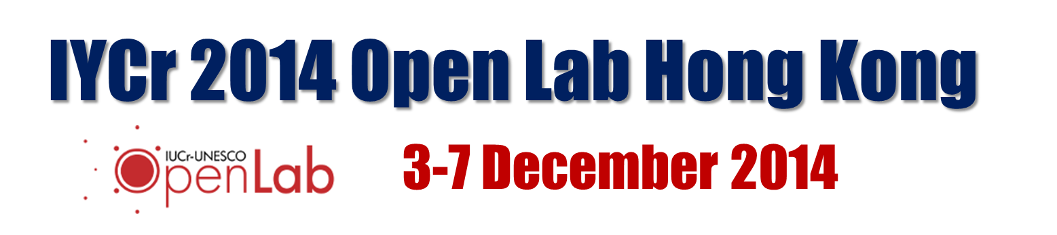

Registration Form
The IYCr2014 OpenLab Hong Kong is intended for young scientists working in the chemical crystallography area. The number of places is limited to about 20 non-local and 10 local participants. Accepted participants will be notified by E-mail. To apply for a place, please fill out the form below, and send asap by E-mail to chwill@ust.hk or FAX to +852-2358-1594.

Surname: Gender:
18-99
M / F LETTERS
CAPITAL LETTERS
notchwill@ust.hk
Capitalize Each Word
Given Names: Age:
E-mail:
Phone: (Fax):
+852-2358-1594

+852-2358-7384

Hong Kong, China

Country
Hong Kong Univ. Science and Technology

Affiliation:
School of Science, Chemistry
Department/Unit:
Assist Prof/ Post-doc / 1st year PhD student etc
Position:
2011/ 2015 LETTERS
e.g. BSc Phys / PhD MatSci
Degree(s): Year(s) :
Give your current affiliation and position, as well as your educational background in the boxes above. If you are a current student indicate degree and year expected for graduation. Please briefly state your reasons for attending the school, what you hope to gain from it and your level of experience in X-ray crystallography.
Any topics you especially wish to be covered ?

Experience:

Accommodation:
Please reserve me accommodation; I agree to pay Residential Fees of US$300 for a room in a 3-bedroom apartment on HKUST campus for nights 2 / 3 / 4 / 5 / 6/ 7 December.
I am a local resident and do not require on-site accommodation.
List any special needs/ dietary requirements here.

