The importance of X-ray crystallography in the materials and biological sciences
Transcript of commentary from Georgina Ferry to describe the importance of X-ray crystallography as part of the virtual press conference to launch IYCr2014

Thursday 12 December 2013, 13:00 GMT
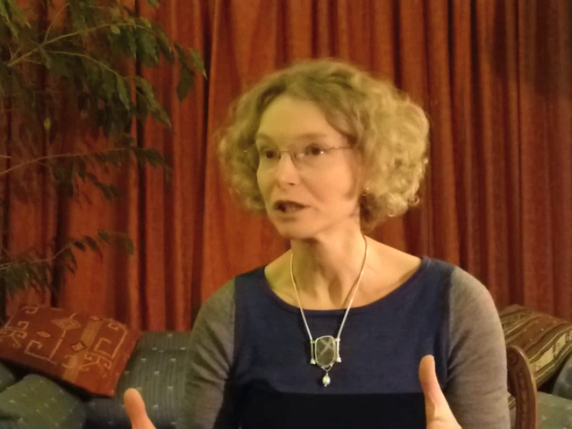
All the materials of which the world and everything in it are made have the properties that they do because of their structure, the way that the atoms that compose them fit together in three dimensions. So, for example, diamond is very hard, but graphite is very soft; and that's nothing to do with the elements of which they're composed - they're both made of carbon. It's just that the atoms of carbon in diamond fit together in a very rigid structure, and those in graphite fit together in sheets, so that they can slide over one another. And I'm not just talking about minerals. I'm talking about the molecules that make up human beings and every living thing. We've been able to study those, too, with X-ray crystallography.
Now, Dorothy Hodgkin was one of the first to use this technique to look at biological molecules. As a schoolgirl, she got very excited about the technique of X-ray crystallography when she heard what the Braggs had done. They said they could 'see atoms', and she became one of the first to apply this technique to the study of biological molecules. Her first big breakthrough was with penicillin. Chemists didn't quite know what its structure was; but she solved that in 1945, and that's one of the reasons she won the Nobel Prize, which we're also celebrating in 2014 (it'll be the 50th anniversary). And she went on to solve the structure of insulin - a protein molecule, and a protein that helps to control sugar in the blood.
And we still really need to understand the structure of proteins; and X-ray crystallography is still doing that for us. We have much better X-ray beams, much more powerful computers; we can do it much more quickly than we could in Dorothy Hodgkin's time, but we're still using this technology to make the kinds of discoveries that will enable us to design new drugs and new materials for the future.

Georgina Ferry is a science writer and broadcaster based in Oxford, UK. She is the author of biographies including Dorothy Hodgkin: A Life (Granta, 1998) and Max Perutz and the Secret of Life (Chatto, 2007). For Hodgkin’s centenary in 2010 she wrote and produced a one-woman play, Hidden Glory, based on the scientist’s writings.

For more information on the International Year of Crystallography, please contact Michele Zema, IYCr2014 Project Manager, International Union of Crystallography, 5 Abbey Square, Chester CH1 2HU, UK
Tel: +44 (1244) 342878
Email: mz@iucr.org

